XXX Secondary School
20xx-20xx
Business, Accounting and Financial Studies
Key Business Functions
Classwork Worksheet: Group Discussion

Name: ___________________ Class: 4___ ( ) Date: ___________________

Read the information of Nissin Group and find out their marketing mix.

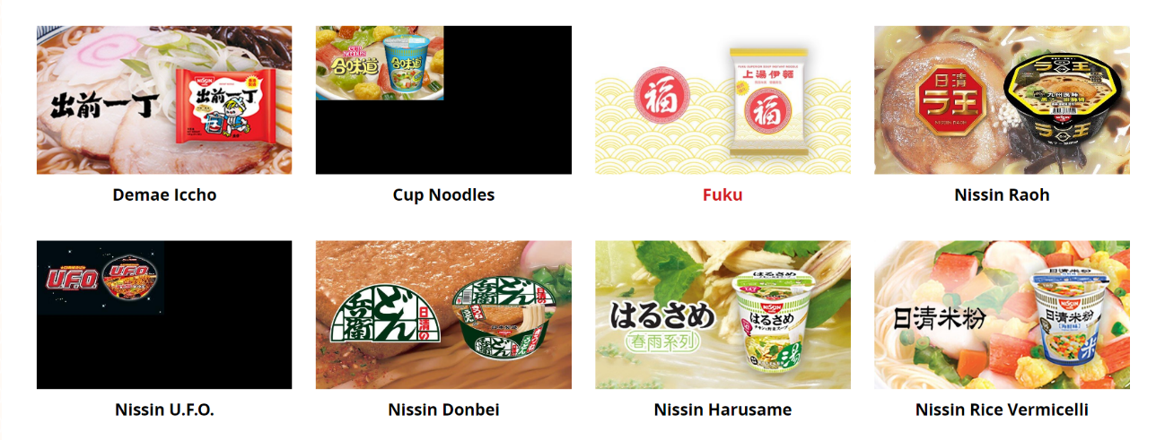
Extract A: Extracted from “Brands &Products” pages of Nissin Group’s website
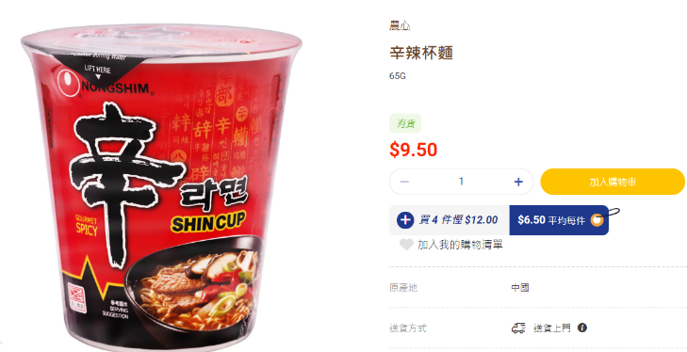
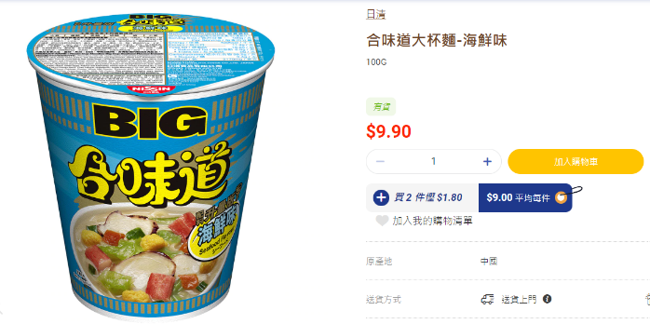
Extract B: Extracted from the website of a local supermarket

Extract C: Extracted from Nissin Group’s website
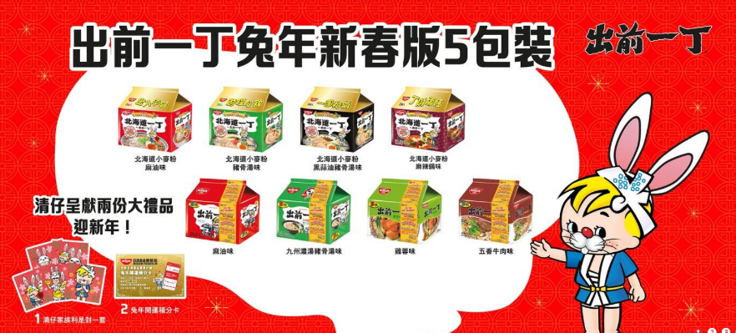
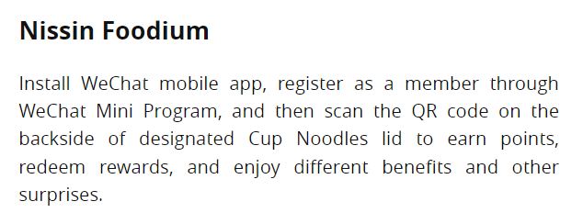

Please discuss and write down the marketing mix (Product, Pricing, Place and Promotion) of Nissin Group.
Place
(Tips: Where can you get the products of the brand?)
Product
(Tips: what does the brand sell?)
Promotion
(Tips: How does the brand promote their products?)
Pricing
(Tips: What is the position and target customers of the brand?)
Compare the marketing mix (Product, Pricing, Place and Promotion) of Tai Hing Group and Nissin Group in the table below.

 | Tai Hing Group | Nissin Group
Product | Different brands which offer different ____________ service. | Different types of ______________________.
Pricing | Position: ___________________  Target customers: ____________________  Comparable to other restaurant groups. | Position: ___________________  Target customers: ____________________  Comparable to other _________________________.
Place | Located in some ___________________ and provision of online ordering services | Can be easily bought from _______________, _______________ and retail shops.
Promotion | Invite _____________ to film the TV commercials.  Launch products with ____________________. | Launch new flavors with special packaging.  Launch a ________________  program through the mobile app.

References:

Nissin Group (2023, March 16). Nissin Group Official Website. https://www.nissinfoods.com.hk/tch/products

Tai Hing Group Holdings Limited (2023, March 16). Tai Hing Official Website. https://www.taihing.com/?route=home#home-banner

